HRMS FRONTEND

HRMS

Deploy the HRMS application in server

* Launch the instance with t2.medium

OS:-Ubuntu

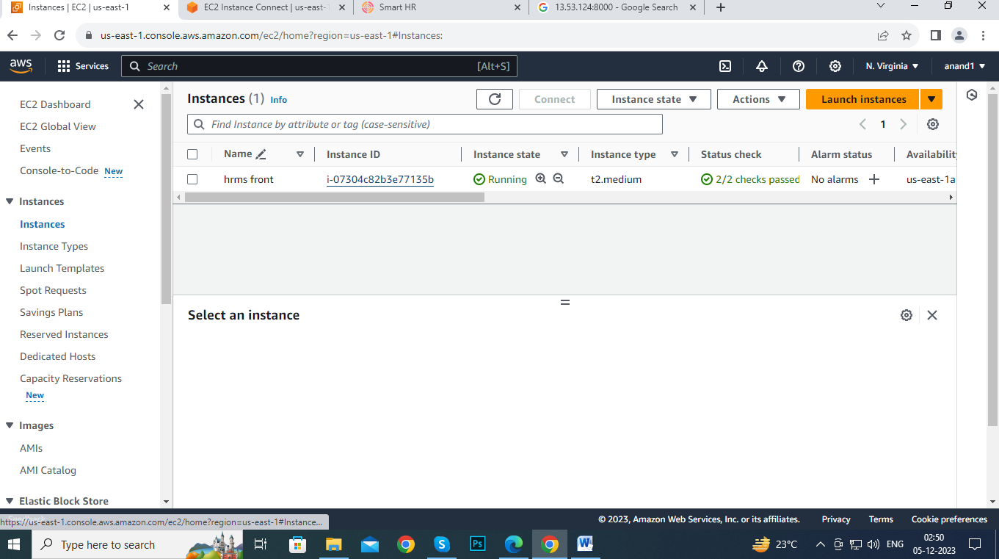

* Connect the instance
* 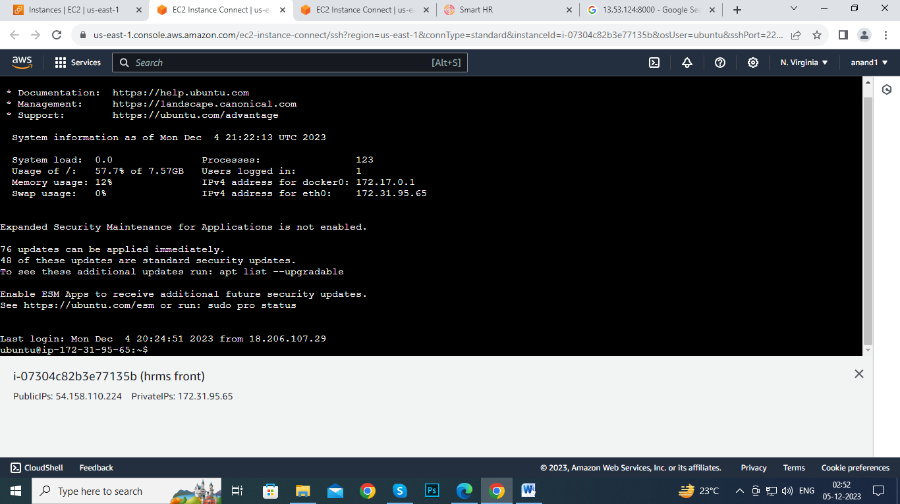

* After connecting instance
* Sudo-i
* apt update

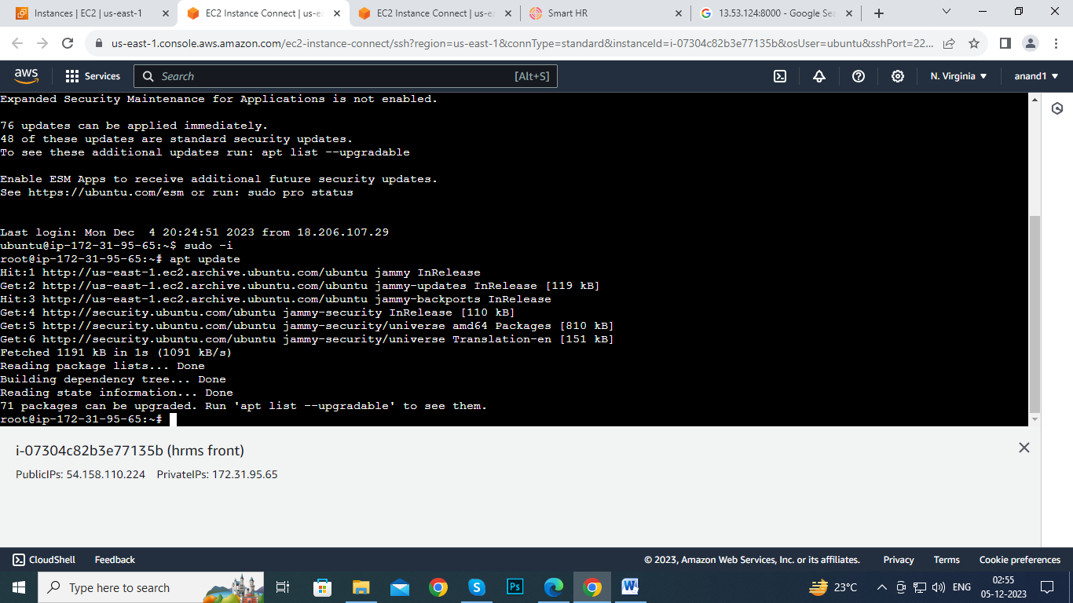

* apt install apache2



* rm -rf index.html
* apt install git
* apt install docker.io –y



* systemctl start docker
* systemctl status docker
* cd /var/www/html

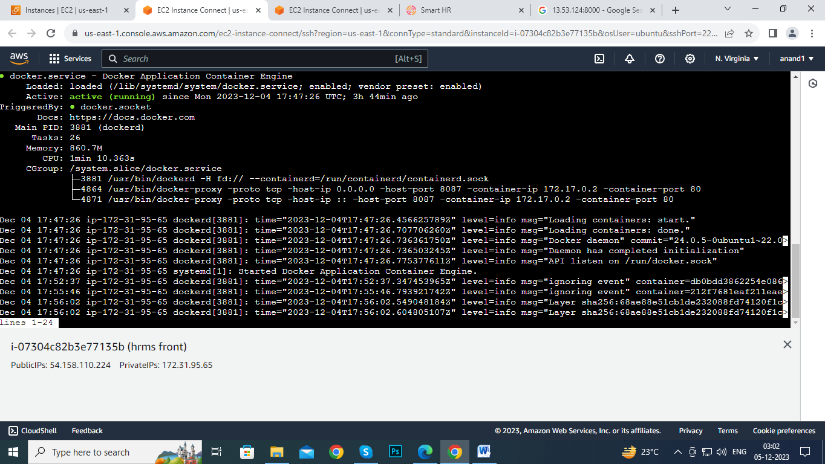

* git clone
* cd hrms-frontend

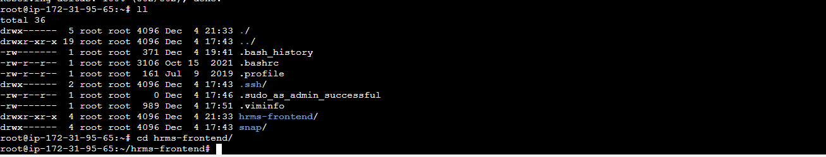

* Creating Dockerfile

Vi Dockerfile

# Stage 1: Build the Angular application

FROM node:latest AS build

WORKDIR /app

# Copy package.json and package-lock.json

COPY package.json .

COPY package-lock.json .

# Install dependencies

RUN npm install

# Copy all the application files

COPY . .

# Build the Angular app

RUN npm run build

# Stage 2: Serve the Angular application using nginx

FROM nginx:latest

# Copy the built Angular app from the previous stage

COPY --from=build /app/dist/* /usr/share/nginx/html/

# Expose port 80

EXPOSE 80

# Start nginx server

CMD ["nginx", "-g", "daemon off;"]

* Docker build .
* 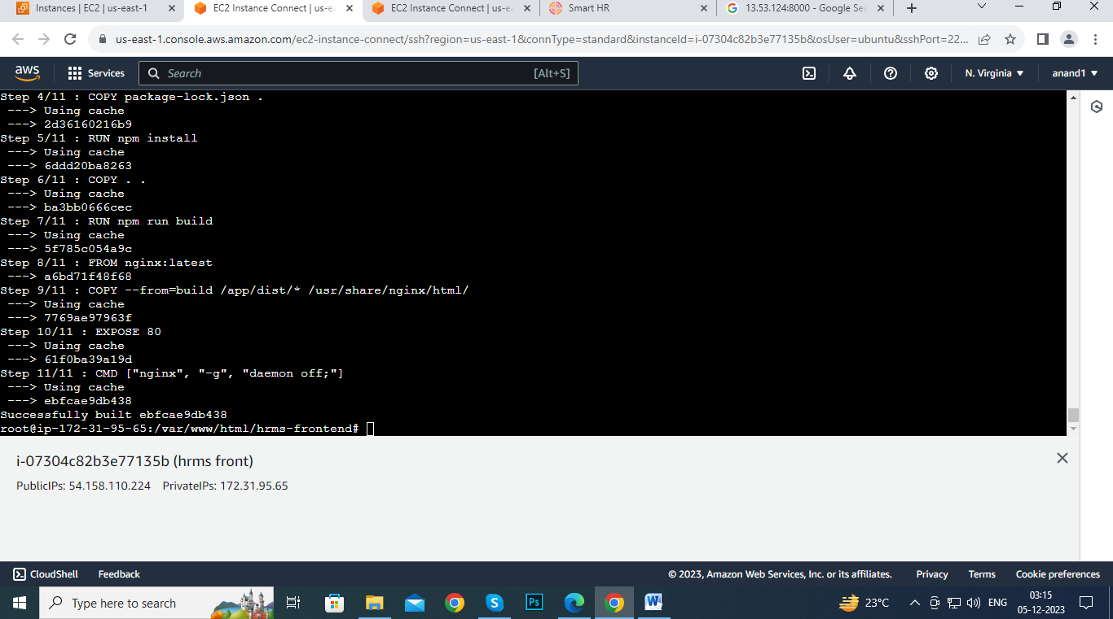
* Docker images
* docker run -itd --name ting -p 8087:80 ebfcae9db438
* copy the public ip address &paste in new tab
* finally I got this output

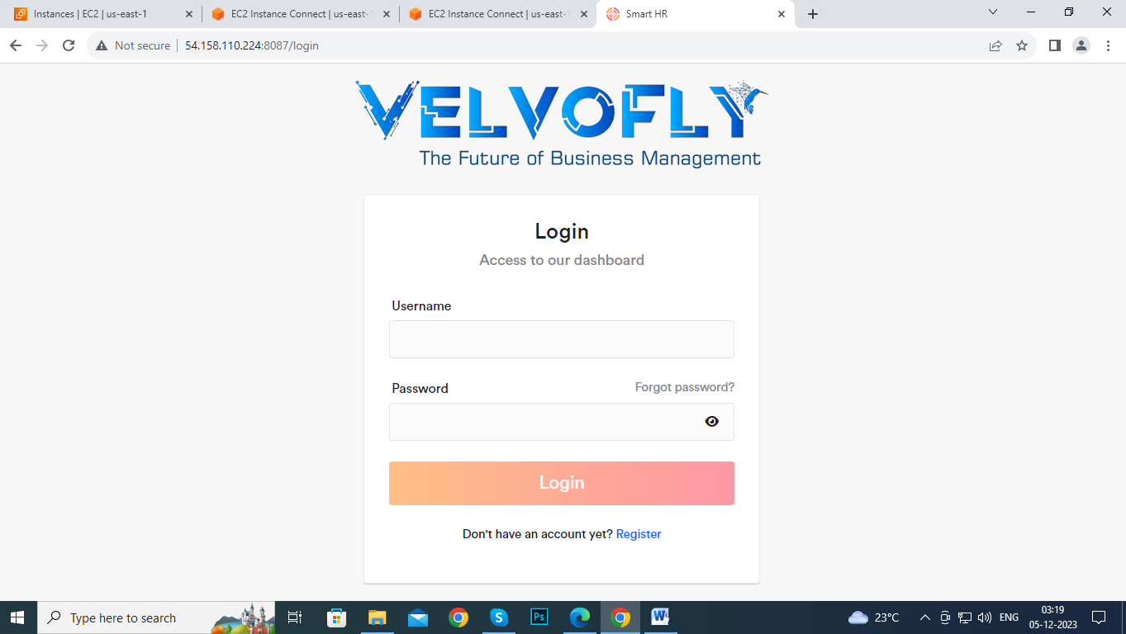

1 apt update 2 apt install apache2 3 sudo apt update 4 apt install docker.io -y 5 systemctl enable docker 6 systemctl start docker 7 cd /var/www/html 8 apt install git -y 9 git clone https://github.com/udayd78/hrms-frontend.git 10 cd hrms-frontend/ 11 vi Dockerfile 12 docker images 13 docker build . 14 apt npm install 15 docker images 16 docker run -itd --name ting -p 8087:80 ebfcae9db438 17 docker ps 18 history